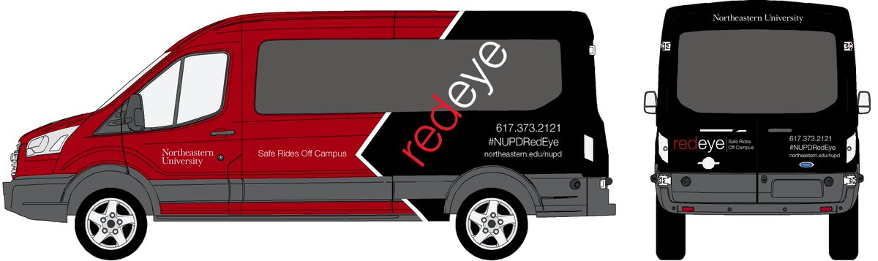

Safety First

IOS app for university shuttle booking

**Project Idea:**

All students at the Northeastern University are provided the convenience of drop off at their specified location within a radius of 1.5 miles between 7pm-6am. The red eye shuttles run from the library and accommodate 10 to 11 people. There are times that these shuttles are overcrowded and students have to form a queue. There is an average wait period of 30 minutes. As a part of my final project I have created an app which facilitates the booking of these shuttles which would benefit in some of the below listed ways:

1. Once a student has a confirmed booking, he/she will not be required to wait in severe cold conditions for more than 5 mins.
2. A student can estimate if he/she can make it in this shuttle and plan their stay in library accordingly.

In order to create this application, I have used the following approach:

**IOS App**

Developed for an app to book the university shuttle at a convenient slot (if seats available), view bookings, cancel bookings.

**Application Design Features**

* Database designed using MySQL
* Apache Tomcat used as local server
* IOS App designed using Xcode
* Java at the backend for server side development

**Database Design**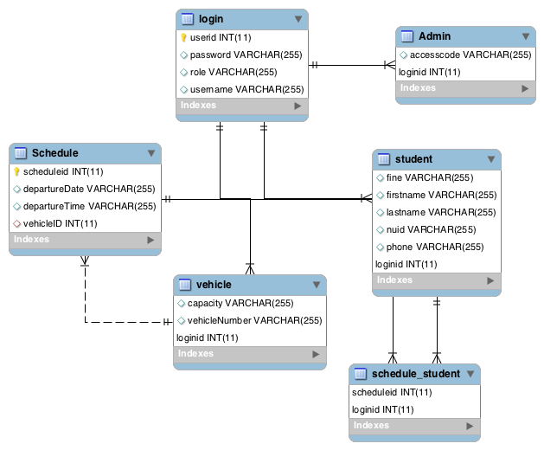

**Functionality**

* Real time utility application for booking the University shuttle in order to avoid wait times by students
* Application has 3 roles : Admin, Student & Vehicle
* Parsed JSON data sent to the server and received from server
* Used Core Image Filter to generate QR code from NSString
* Used AV Foundation framework to implement bar code scanner
* Implemented calling functionality from the app

**Application Workflow** 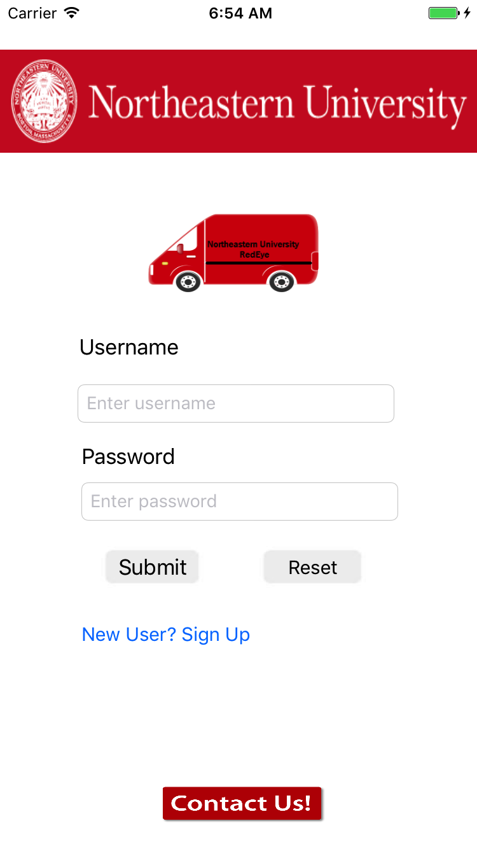

The application has 2 sign up options

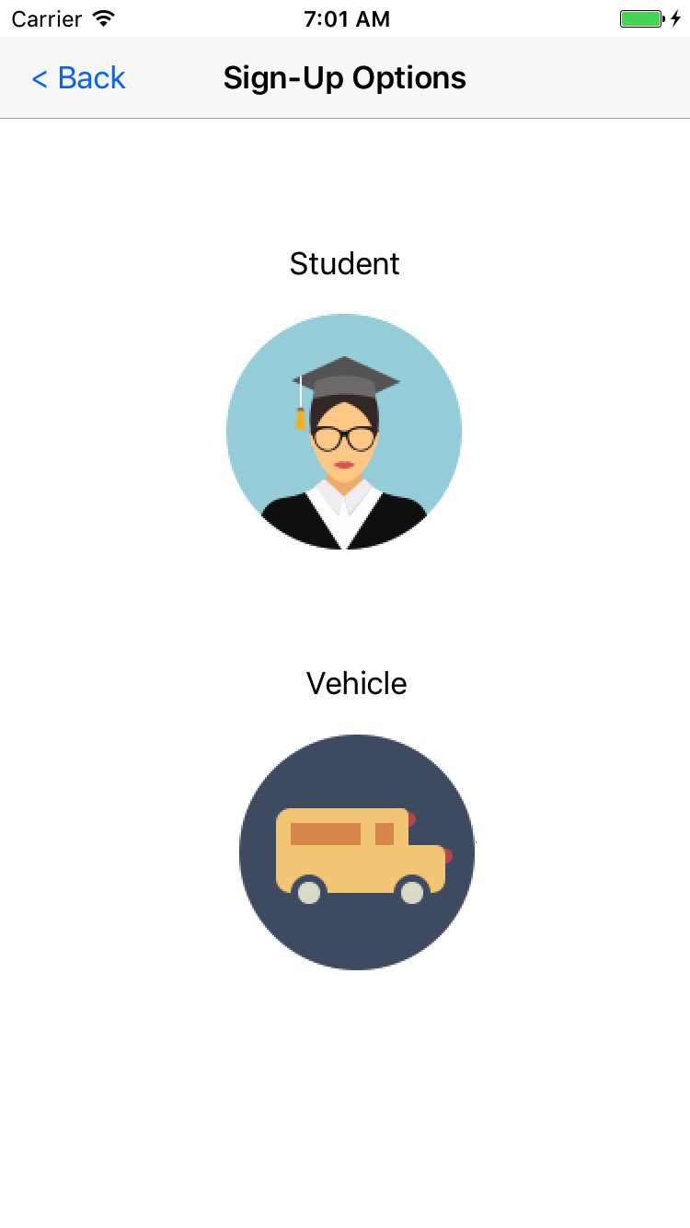

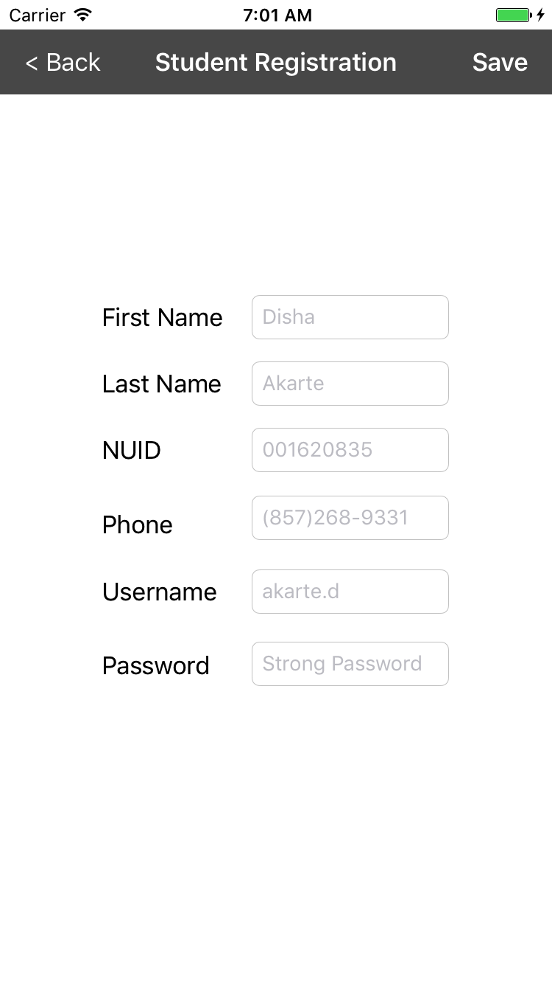

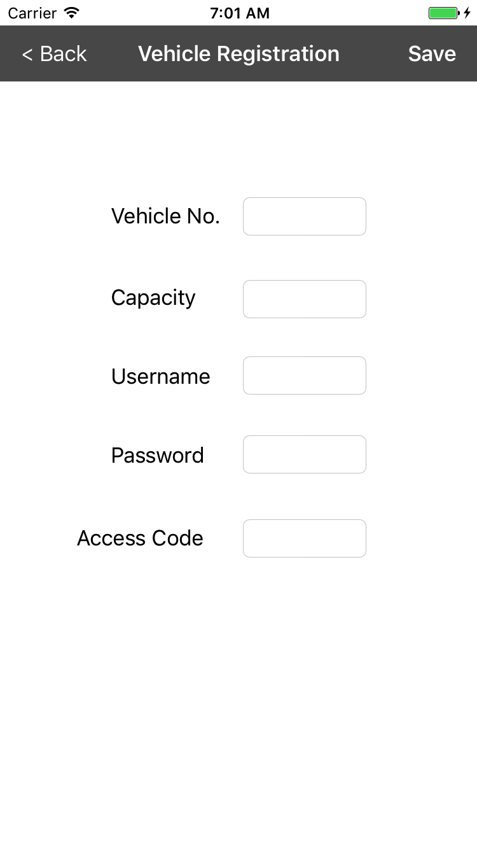

1. There are separate roles for the admin, students as well as shuttle drivers.
2. There are separate logins for the admin, students as well as shuttle drivers.

* Admin post login screen

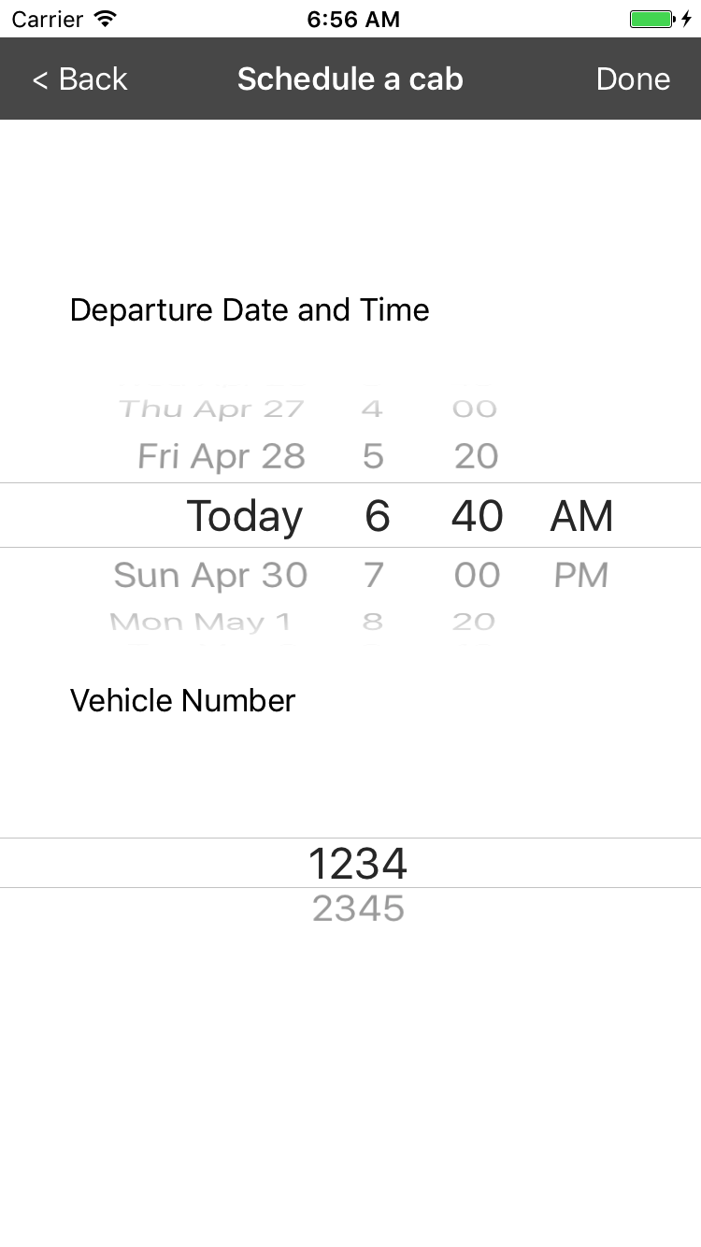

-Student Login Screen

1. User can see the personal information and a bar code generated using NUID

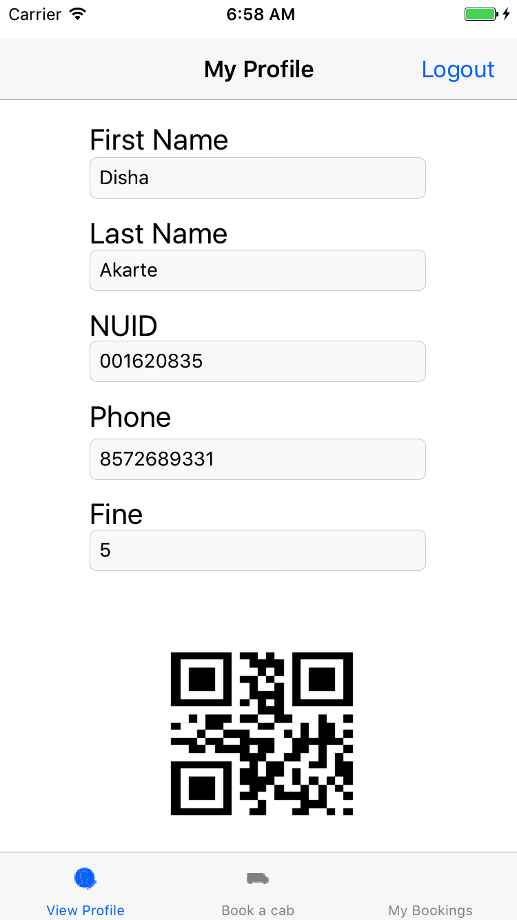

A user can check the availability of schedules by selecting o=values from the picker and book the cab if available.

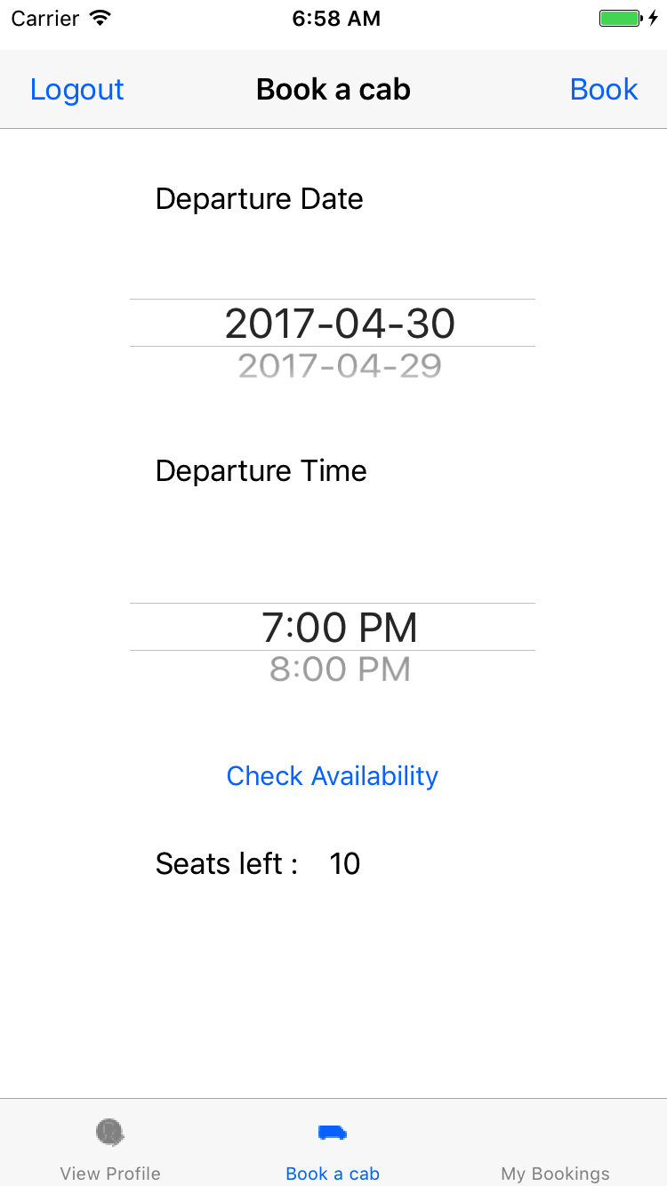

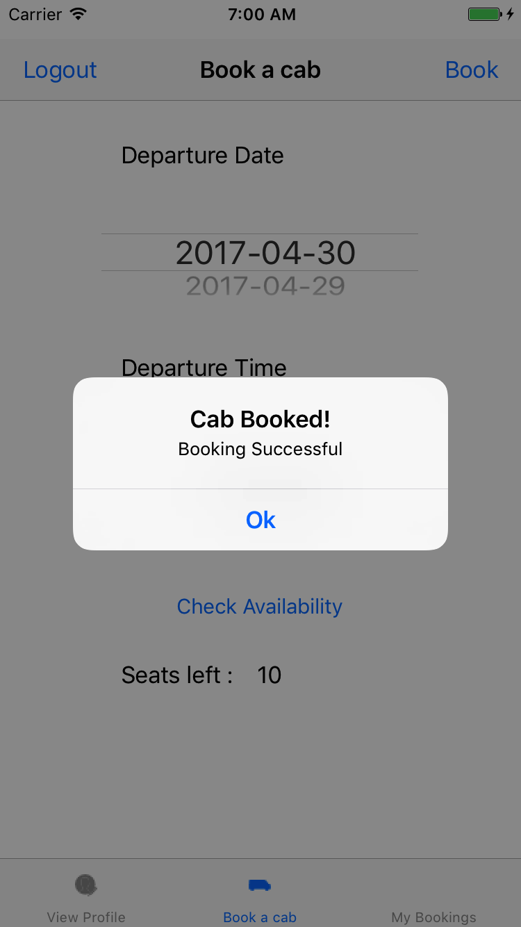

User’s booking list of cab gets updated after adding a new booking

View Details

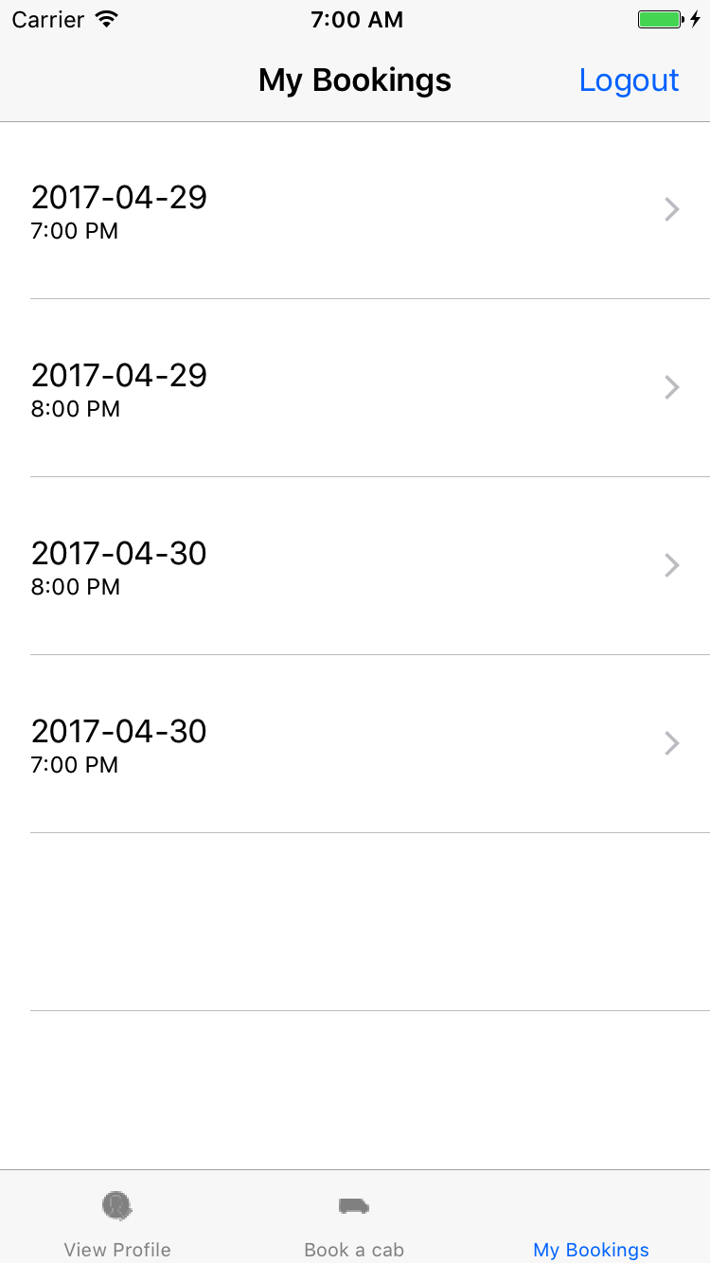

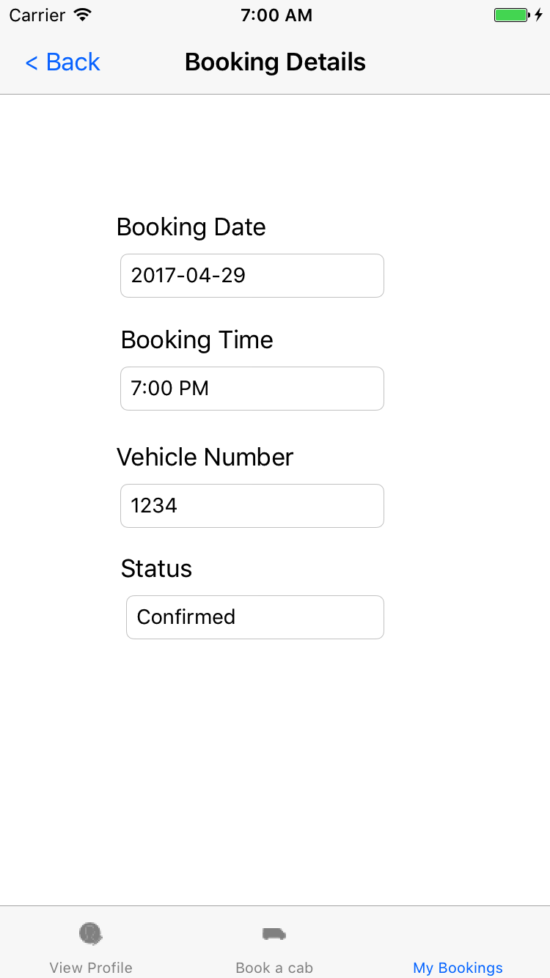

User can also delete a booking  
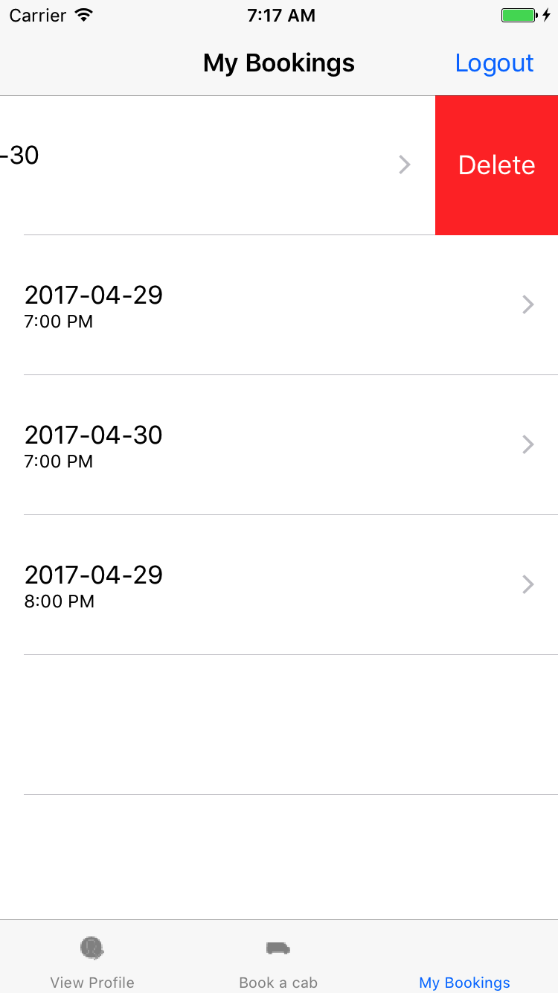

1. Vehicle login can see the list of riders and also apply fine is a rider did not turn up for cab.

